

ANDRIOD APPLICATION

**USER MANUAL**

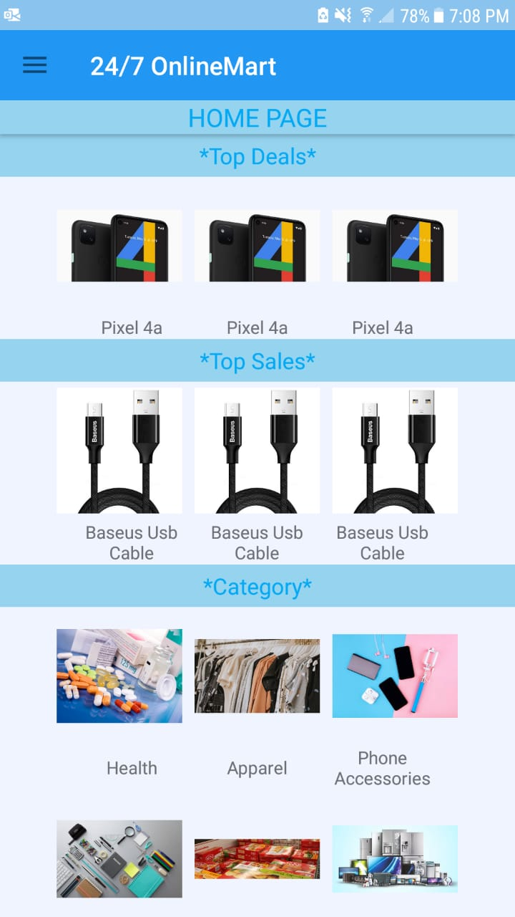

TABLE OF CONTENTS

Section 1

Sign Up View 3

Section 2

Login View 3

section 3

Home Page 4

section 4

Category Browser 5

section 5

Cart View 5

section 3

Orders View 6

section 3

E-Wallet View 7

section 3

User Settings 8

1. **Sign Up View**



Instructions:

* Once user navigates into the app, click on the sign up button to navigate to the Sign Up page.
* Fill the required fields and click on Signup button to complete the process.
* You have made the account successfully.

1. **Login View**



Instructions:

Once you have made an account, click on the login button.

* Fill the required credentials, and press login.
* You will be redirected to the dashboard.

1. **Home Page**

Instructions:

* Real-time view of all the latest items, popular items and offers.
* The side navigation bar reveals the different components and pages of the application such as user settings, cart, wallet, and more.
* Click on the item to go to its respective details.

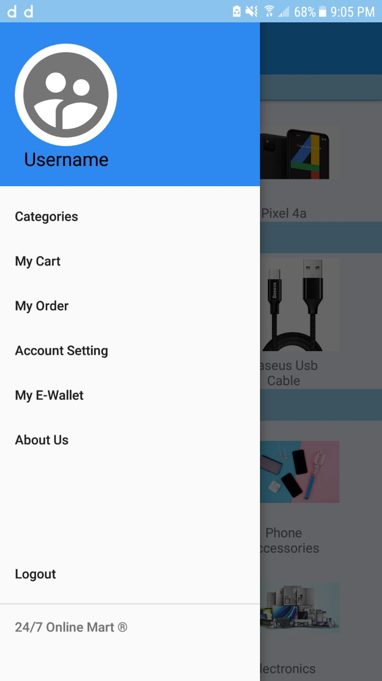

1. **Category View**



Instructions:

* The Category tab enables to explore the items of the respective category.
* Click on the category to browse the contents inside the category.
* You can see the item description, stock, price, and related information inside the product view.

1. **Cart View**

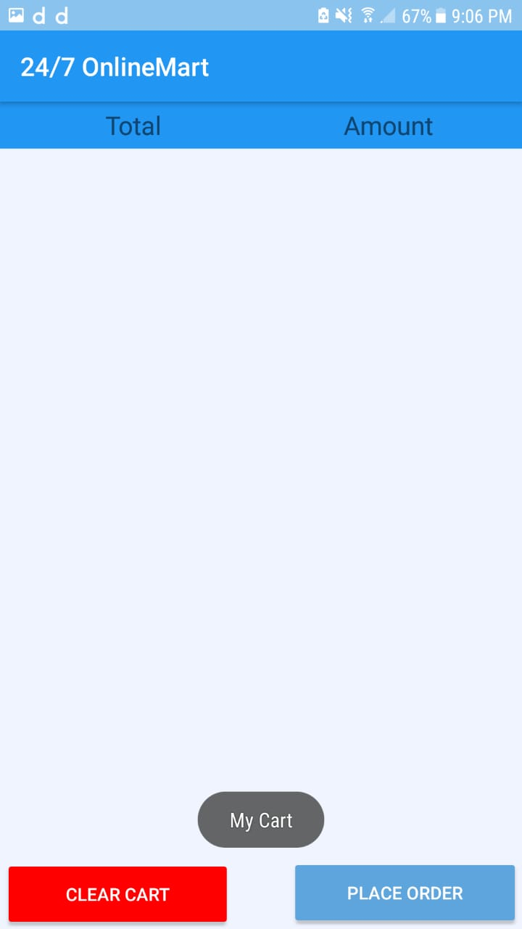

Instructions:

* Click on the side navigation menu bar and select My Cart.
* Click on the Clear Cart button to remove all the elements inside the cart.
* Select the items and click on “Place Order” to proceed to checkout.

1. **My Order View**

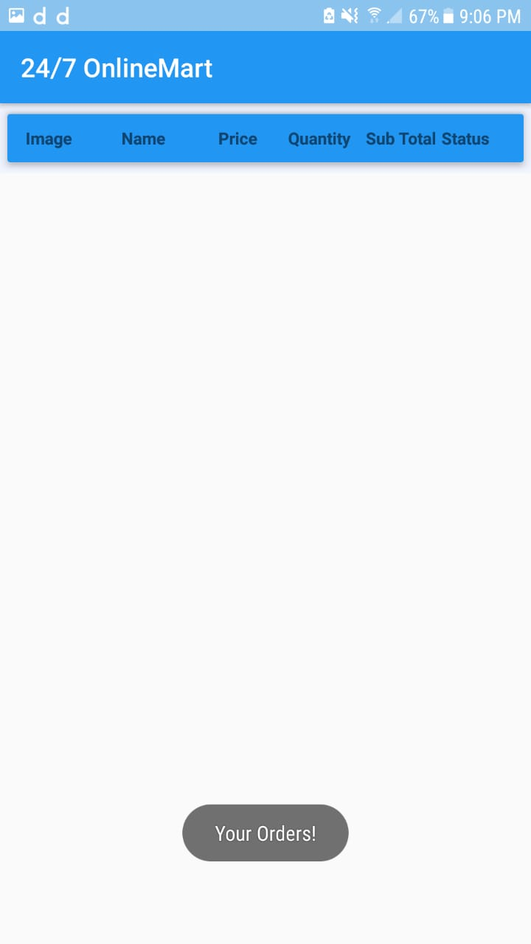

Instructions:

* Click on the side navigation menu bar and select My Orders.
* You can check your order details on the page.
* Click on the item to redirect to the item page.

1. **E-Wallet view**

Instructions:

* Click on the side navigation menu bar and select E-Wallet.
* You can check your remaining amount of cash in your e-wallet.

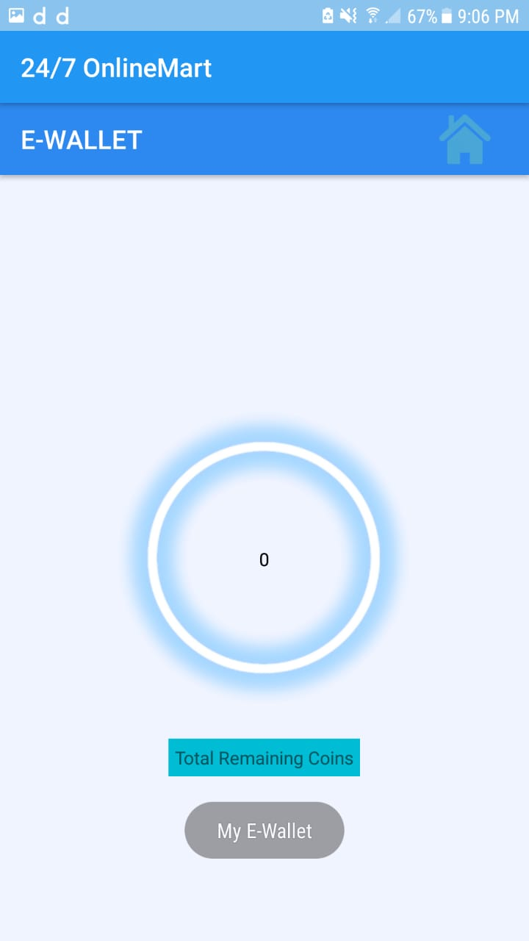

1. **User Settings**

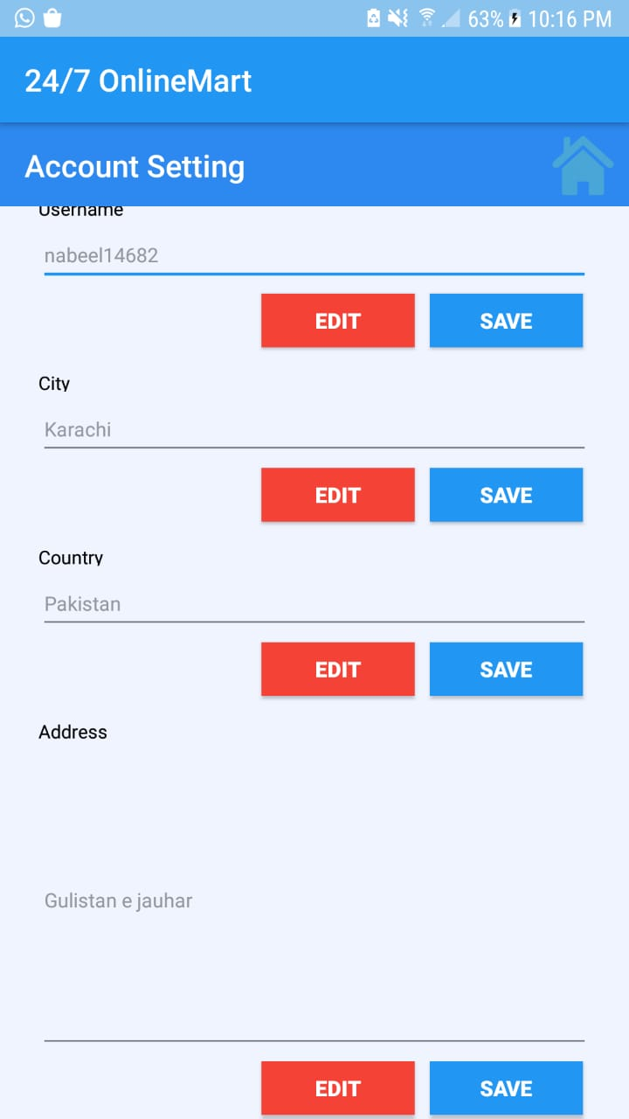

Instructions:

* Click on the side navigation menu bar and select Settings.
* To change the respective field of information, fill the text boxes.
* Once done, click on save button to save the information.